**LAPORAN PRAKTIKUM**

Nama : Maftuchati

NIM : 18090015

Kelas : 5B

**PRAKTIKUM 1**

1. Source Code

perkenalan.php -> application/controller

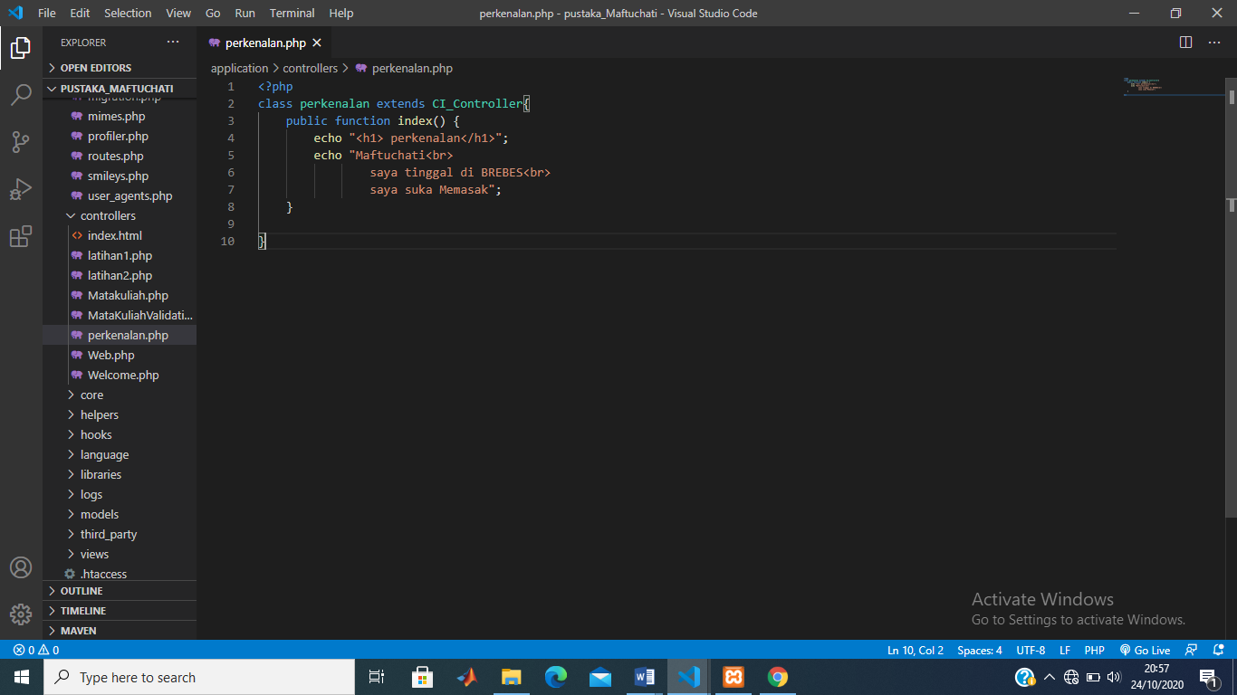

1. URL

<http://localhost/pustaka_Maftuchati/index.php/perkenalan>

1. Capture Hasil 